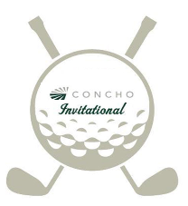
Sixth Annual
Concho Invitational

Concho Resources is proud to present our sixth annual Concho Invitational Golf Tournament to be held June 23rd and 24th, 2017 at the Artesia Country Club in Artesia, New Mexico. The format for this limited entry tournament is a 3 Man Scramble on Friday and a 3-Man Select-Drive Two Low-Ball on Saturday.

This tournament has benefited multiple local charities and Concho invites you to help continue the success of this annual event with contributions through a sponsorship.

For this year’s tournament we have available a $1,500.00 sponsorship which entitles you to one (1) paid team entry, player bags and Friday night dinner for player and a guest. A player’s lunch will be provided by vendors during each round. Also, your sponsor sign will be placed prominently on the course. As an added benefit sponsor team will be given priority into the tournament.

Should you be unable to sponsor, but would like to participate in this tournament we will be accepting team only entries when accompanied with $1,200.00 entry fee. However, we anticipate the tournament to reach capacity and will be giving sponsored teams priority.

Thank you for considering this tournament as an opportunity to benefit local charities. However should these levels be unattainable and you wish to help local charities, please contact us with inquiries at conchogolf@concho.com or 575- 748-6940.

Concho Invitational 2208 West Main Street Artesia, NM 88210

